**Unit 1**

**Grammar: Direct and indirect questions**

**Exercise 1**

**Complete the sentences**

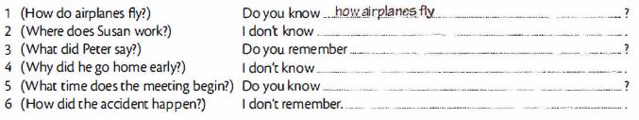

**Exercise 2**

